The Story:
You’ve lost your jacket. You’ve lost your job. You’ve lost your favorite pair of British Knights.

You’re Chas DeWitt, recently laid-off interstellar trucker, and you’ve just had the worst day of your life. All you want is a measure of pride and perhaps some personal satisfaction, so you decide to single-handedly take down the corporate mogul who’s cost you your all-too-cushy paycheck. This mogul is “Bob”, a mysterious investor who is gathering up a galactic monopoly like it’s going out of style, and he’s doing it by investing in companies who have fallen prey to a mysterious and eerily effective space pirate.
Along the way you’ll be joined by friends and unlikely allies, hopping from star system to star system, relentlessly pursuing “Bob” as you unravel the secrets behind the greatest corporate merger in galactic history.

The Game:
This version of the game is still an early Alpha, but the most complete. Most of the videos are rather rough (some cleaner versions are on this disc). Characters, as they were created in a separate modeling program, were not inserted into scenes for the most part. You might not be able to see many of them, but they’re there and the player must be able to interact with them to complete their objectives. The only clue to their presence is that the mouse icon changes to a word balloon, with the appropriate action name appearing on the control panel.
Also missing are the cut scenes of what’s happening on Bob’s end of things. There’s a very meticulously planned story in place, and by playing what is presented here the player is only getting half of it. These would have been interspersed at several points throughout the gameplay. Eventually events from these cut scenes will have tangible effects on the game, so they are indeed more than mere cinematics. A few test shots and videos of Bob’s ship and crew are also on this disc.
With as much as has been completed, Chas and crew barely get started before the game is essentially over. Chas never gets to meet his nemesis. Events from early on in the game and the choices the player makes in response to them would have profound effect by this point, making the end all that more difficult to attain – or far more satisfying.
Char(10) and Char(13) represent “the end of the line”. It’s no coincidence that they also end this page.
1) The Main Action Window  This game is entirely controlled by the mouse.  Point and click to:  Change location, talk to characters, pick up objects  Drag and Drop to:  Use inventory items  Interface:  - The Location bar displays the name of your current location, and changes only when your location does.  - The Action bar displays the action you can perform, changing as the mouse moves over “hot spots” in the Action Window. | 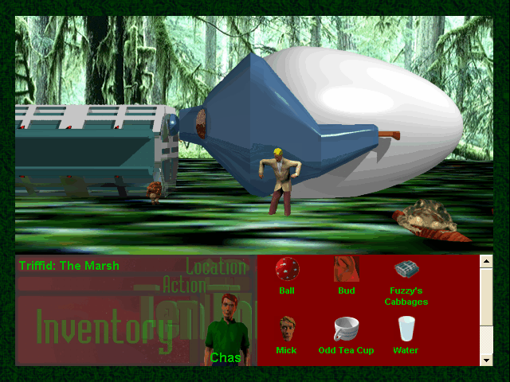

2) Dialogue  Much of the game action is driven through dialogue with other characters. Sometimes there is only one “path” through a conversation. Other times there are many outcomes, which range from getting different inventory items to outcomes that may not become apparent until later in the game.  Interface:  - A red Dialogue window that displays the phrases of other characters. It appears in the lower-right of the Main Action Window.  - Up to 5 possible responses that your character can make to any given phrase. Click on one of these to select a response. If there is no more interaction | 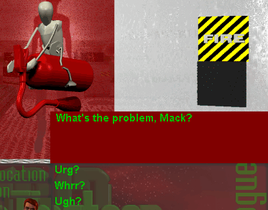

NOTE: The player is unable to perform any other actions until the dialogue has ended.
3) Narration  Interface:  - A green Narration window that displays each phrase of a Narration. It appears in the lower-right of the Main Action Window, the same location as the Dialogue Window.  - Click on the Narration window to progress to the next Narration phrase. Do this until the narration has completed (the window will disappear).  NOTE: The player is unable to perform any other actions until the narration has ended. | 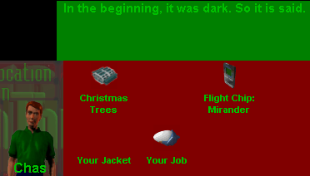

Much like the red dialogue window, a green Narration window will occasionally appear on the screen. Also like dialogue, the player will not be able to perform any actions until the Narration is over. Clicking on the narration window will proceed to the next phrase, or if there is no more narration the window will disappear.

4) Inventory

Interface:
- A red field that (currently) occupies the same position as Dialogue responses (this field disappears during a Dialogue).
- Click and drag an inventory item over the Action Window or the Character Image. If the item can be used, the mouse icon will turn into a plus sign. If the item cannot be used, the mouse icon will change to a stop sign.

Dragging the item over the Character Image will perform one of three actions:  - Use that item on the Character  - Combine an item with another item  - Examine the item | 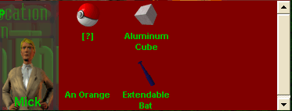

(This multiple functionality is not a preferable way to handle each case, and was corrected in a later interface prototype. One inventory item that comes to mind will kill you if another item is not present, but will instead mix with that other item if it IS present.)
5) Ship Navigation  Interface:  - Appears in the same place as the Main Action Window and has the same functionality.  - Click on one of five available star systems.  - Once a star system has been selected, there are many destinations – typically only one planet and a nearby satellite. Once a location is chosen, it is safe to leave the ship. | 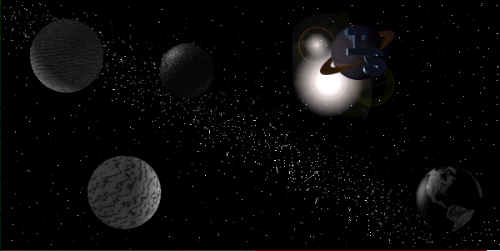
Though all five available star systems are visible on this screen, they will not become active without a Flight Chip. Flight chips are collected during the course of the game. To use a flight chip, drag-and-drop it from your Inventory to the slots on the ship’s control panel under the Navigation screen. That star system is now a viable destination.  Flight Chips cannot be removed once inserted into the panel. | 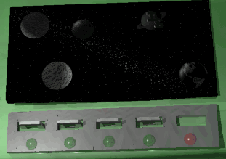

6) Saving, Restoring, and Ending the Game  Next to the navigation screen on the ship are three buttons:  - Yellow Button: Restore a saved game  - Blue Button: Save current game  - Red Button: Exit game. A popup will ask you to confirm this action. | 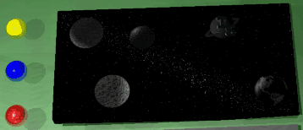

7) Animations

Animations happen during certain events, such as navigating the ship. To skip over these videos, click on the video with the mouse.

8) Hints and Recommendations

General Adventure Game Rule #1: Save early, and save often!
- Certain actions will cause the death of your character, at which point the game is over. Restoring from a save point is the only way to continue.

General Adventure Game Rule #2: Explore every option!
- There are sometimes multiple ways to accomplish the same goal. Which method you decide will limit or expand your options later in the game.
- Don’t just rush through the game! There are plenty of fun things to do along the way, some of which you can never revisit once you’ve progressed. In such cases, see rule #1!

General Adventure Game Rule #3: Don’t give up!
- If a puzzle seems impossible, do not despair! In this particular game, you haven’t reached the “end” (i.e. the part where there’s no more game programmed, but more was intended) until Timothy joins your party. There’s nothing else to do but revisit old locations at that point. Up until then, there’s plenty of game to explore!
- If you feel hopelessly stuck, remember to:
  - Try to use an inventory item, either on yourself or other characters.
  - Revisit old locations to see if you missed anything. Sometimes new events will occur due to what you’ve done in the interim.
  - Try different lines of dialogue with characters. You might not have said the right thing yet. You won’t be able to talk to certain characters until you “know” something relevant to them beforehand.
  - Call me and complain.

Necessary Hint #1: Most people get this, but some don’t. What does one do at a bar? Do that, and you’ll get unstuck quickly.

Necessary Hint #2: Almost every person who has played the game has gotten stuck at this point, and sadly it’s quite early on. You will be asked to fetch an item for someone, but it’s one you have to create yourself from Inventory. If you recall the example in the Inventory section of this document, you’ll be well on your way to figuring out what that is.

Necessary Hint #3: At another point later on you’ll have to switch the character you’re controlling. The mechanism for doing this was never finished -- you’re supposed to be able to do it at will with whoever is in your cadre. There were *big plans* for this functionality, but alas... As a substitute you need to talk to the character you want to play. This will only happen at a certain “dead end” involving a new planet you’re visiting with a friend. If you’ve snooped around a bit earlier on in the game, you’ll be given a hint as to who this person might be.

